EXPERIMENT- 10
1.
# Dataset
survey <- data.frame(
SurveyID = c(1,2,3),
Question1 = c("A","B","C"),
Question2 = c("B","A","A"),
Question3 = c("C","D","B")
)
# Frequency of Question 1 responses
q1 <- table(survey$Question1)
# Grouped Bar Chart
barplot(q1,
beside = TRUE,
col = c("red","green","blue"),
main = "Distribution of Answers for Question 1",
xlab = "Responses",
ylab = "Frequency")
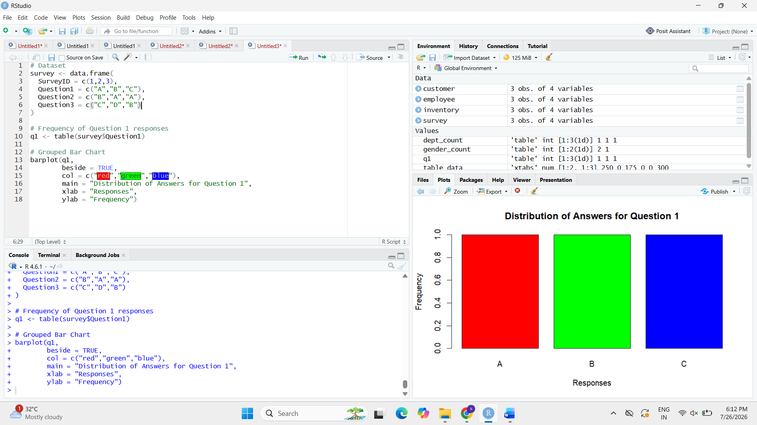
2.
# Dataset
survey <- data.frame(
SurveyID = c(1,2,3),
Question1 = c("A","B","C"),
Question2 = c("B","A","A"),
Question3 = c("C","D","B")
)

# Create response table
response_table <- rbind(
table(survey$Question1),
table(survey$Question2),
table(survey$Question3)
)

rownames(response_table) <- c("Question1","Question2","Question3")

# Stacked Bar Chart
barplot(response_table,
col = rainbow(ncol(response_table)),
main = "Responses for All Questions",
xlab = "Questions",
ylab = "Frequency",
legend = colnames(response_table))

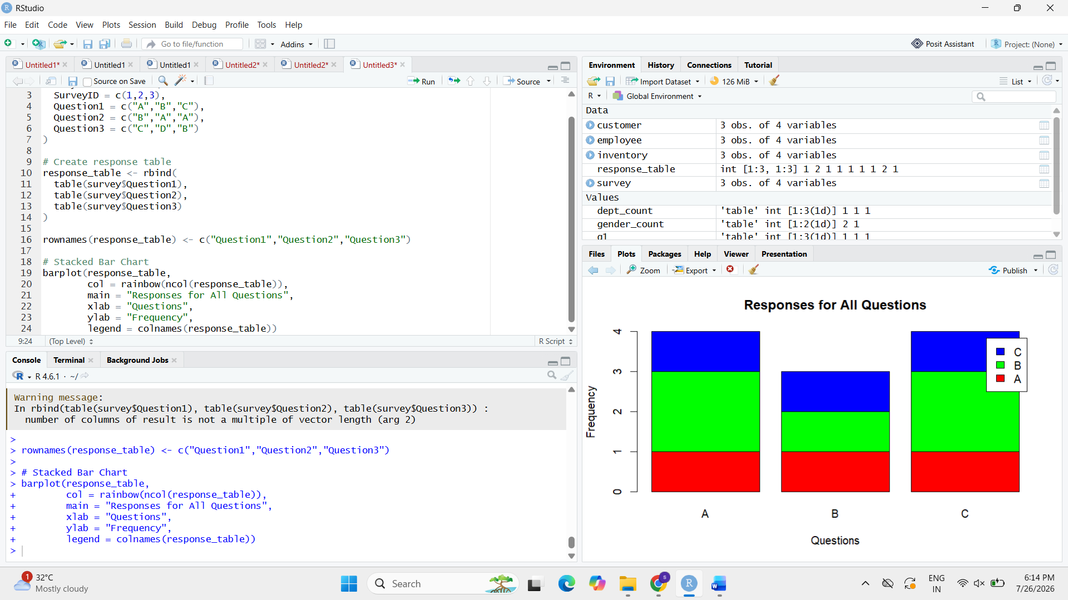

3.
# Dataset
survey <- data.frame(
SurveyID = c(1,2,3),
Question1 = c("A","B","C"),
Question2 = c("B","A","A"),
Question3 = c("C","D","B")
)

# Display Table
print(survey)

